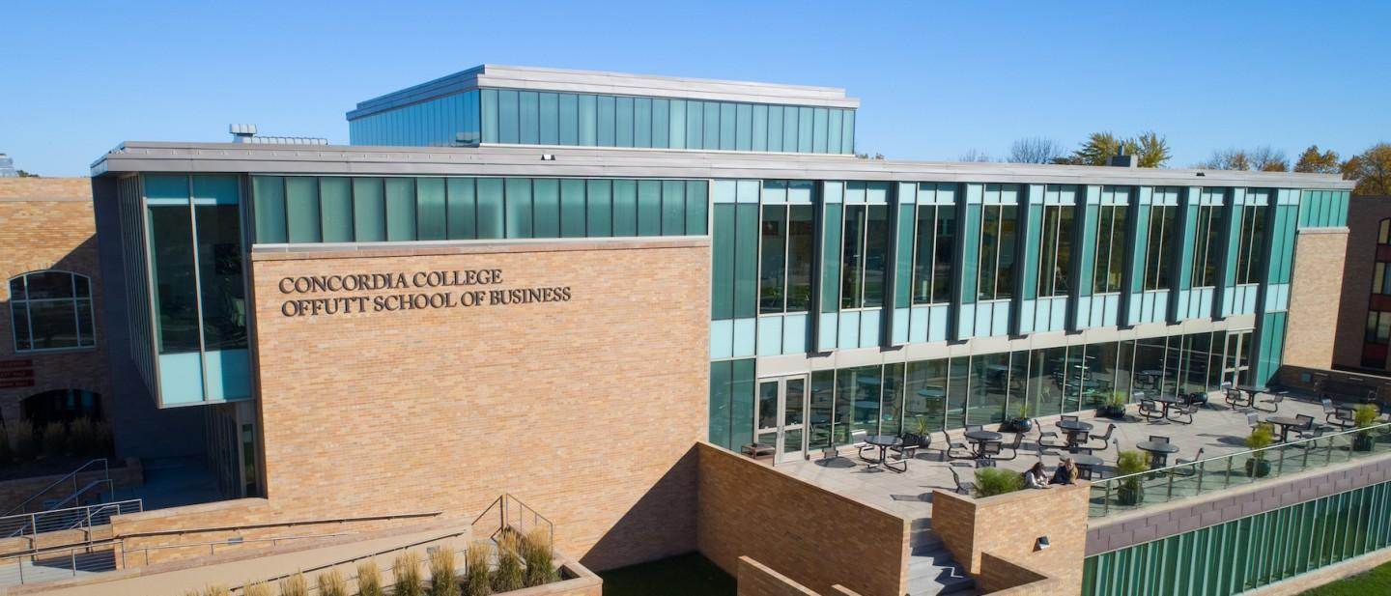

|  |
| --- |
| Inventory Tracker n Helper |

|  |  |
| --- | --- |
| Course | **CSC 225 – Fundamental Structures** |
|  | |
| Team Name | **Randos** |
|  |  |
| Team Members | **Mitch Porter** |
|  | **Kadar Yusuf** |
|  | **Ethan Amundson** |
|  | **Pedro Ochoa** |

|  |
| --- |
| Executive Summary |
| Your executive summary should resemble an elevator pitch: your motivation is to quickly persuade a decision maker to get involved in your project.  Have you ever walked into a grocery store, and seen them throwing away expired food? or “scanning items out “ at a gas station? We have these stores where workers put expired food all the time into bags and scan it out,which is wasting tons of product that could have been a profit. Even any sort of plastic being wasted that wraps these products. TO HELP MINIMIZE this from occurring, we have decided to aim our project at doing this.  What is the purpose of your project? What problem(s) does it address?  The purpose of this project is to help grocery stores as well as gas stations, to minimize the amount of product purchased that they sell and the extra product they throw away. It does not only help the profits made by the grocery stores or gas stations, hopefully reinvesting in a different side of their own stores. It could help eliminate any plastic used to store the product.  Why is your project important? Why is it relevant?  This project could help the stores reinvest the extra money in their own employees, or surrounding communities that shop at their stores. It could also help minimize the amount of food wasted, but more importantly minimize the waste we humans use for no reason, to try and help the planet? Why wouldn’t this be relevant? |

|  |
| --- |
| Background and Problem History |
| Explain the problem domain and relevant background information about your project.   1. In the United States, between 30 to 40 percent of food produced is wasted. 2. Americans throw away almost twice as much food as any other developed country. 3. Total food loss is valued at $218 billion in the United States as to $31 billion in Canada. 4. 18 to 28 percent of our viable cropland is used for growing wasted food. 5. The USDA estimates that about 4 percent or 66,500 acres of planted crops are left unharvested each year. 6. A study in Minnesota found that up to 20 percent of fruits and vegetables are too large, small, or don’t otherwise meet cosmetic standards, and thus aren’t viable. 7. 30% of a grocery store’s trash is food waste.   -keep in mind how crises could affect on overstocking or understocking shelves with materials that shoppers feel they need  - 10 percent or 43 billion pounds of food in grocery stores will never make it off the shelf. For produce, about 12 percent of fruit and 11.5 percent of vegetables are never sold.  Provide a brief history of the problem; when did it start? What attempts have been made to solve it?   * According to Utah State University, the food waste began in the late 1800s and early 1900s. Because that's when food became commercialized and changed how Americans consume food. * According to a Michigan State University, 88% of Americans are trying to reduce food waste. * Food waste is 8% of the world's greenhouse gas emissions. So, some things people have done to handle the waste that is created correctly. * Some of it includes Everything from recycling programs to giving restaurant scraps to animals. |
|  |

|  |
| --- |
| Solution |
| How does your team plan to solve the problem?  We plan to create a program that tracks the amount of food purchased for the store's own inventory and what they sell. At the same time, track the amount that is being sold monthly, weekly, daily, possibly looking towards even hours. This will show us if the products are not as in demand as others, which one is running low in the stores inventory and to put in extra orders by the stores. We can use this program to help reduce the amount of money wasted, and food.  What makes your approach different from other solutions?  We know that the usual way that the stores track their inventory is by having their own employee’s scan out the items by hand, unless they either miss the expiration date and sell it unknowingly. With our program, it will serve as a helper for the stores to further prevent wasting food they purchased. This will allow us to electronically track all the good and bad foods, rather than doing it all by hand. |

|  |
| --- |
| Project Deliverables |
| What will be the “product” of your team’s project? What documents will you create?  -A system inventory? Counter? A number of items allowed in system? |

|  |
| --- |
| Success Criteria |
| How will your team define success? What aspects of your project can you quantify to objectively measure success?  -A system inventory? Counter? A number of items allowed in system.  Our definition of success is that we save 90% of food wastage from grocery stores by using our program. This will save companies a lot of money and make a huge difference in food waste therefore helping our environment and the planet as a whole. This application will not only increase sales for grocery stores but should also be more efficient for the customers and the environment as a whole. |

|  |
| --- |
| List of Required Project Resources and Materials |
| What resources (books, websites, data sets, problem domain information sources, software, etc.) will be required to complete your project?  We will require data sets of all the inventory including expiration dates.  We will require software to track the number of sales for each item.  We will require someone to input data.  We will require pricing data for different items. |